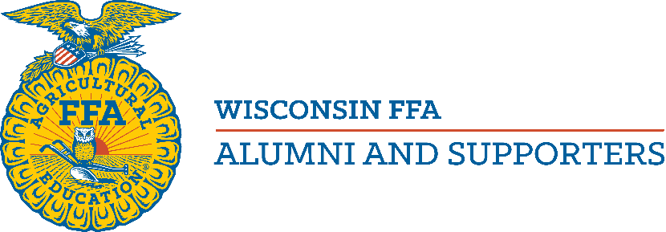

State Level Outstanding Chapter Award
~ THIS APPLICATION IS NOT FOR NATIONAL LEVEL COMPETITION ~
If you are applying at the national level, you are not eligible for this award.

Wisconsin FFA Alumni and Supporters sponsor this award to recognize outstanding chapters not applying at the national level.
The purpose of this award:
- Recognize the positive partnership between the FFA Alumni and Supporters, and the FFA Chapter
- The signature of the FFA Advisor and FFA Officer validates the relationship and partnership between the two organizations

Name of chapter:
Mailing address:
Contact Person:
Phone: E-mail:
Number of members (on current roster) ____

Rules
To be eligible for this award, a chapter must have submitted its membership and payment of fees to the Wisconsin FFA Alumni and Supporters office by November 1.
No single event may be listed more than one time on this application. (For example: Attending an alumni workshop at National Convention cannot be counted as both “attending an official alumni event at National Convention” and as “alumni training,” but attending that workshop and the Alumni Awards Presentation could be counted as both.)

Signatures
We, the undersigned, have reviewed this State Level Outstanding Chapter Award application and attest that, to the best of our knowledge, it has been completed truthfully.

___________________________ ___________________________________
FFA Alumni Officer -Print FFA Alumni Officer – Signature

___________________________ ___________________________________
Agriculture Instructor -Print Agriculture Instructor - Signature

___________________________ ___________________________________
FFA Chapter Officer -Print FFA Chapter Officer - Signature

Section I: Assistance to FFA and FFA Advisor
A. Describe up to 5 events where Alumni and Supporters and FFA members worked together on FFA or agriculture education activities. Include the number of FFA members, FFA Alumni and Supporters, and the total number of alumni hours involved in the activity. (25 points possible)
1.

2.

3.

4.

5.

Points Earned __________
B. Describe up to 5 times that the Alumni and Supporters provided financial support for the local FFA, local FFA members, or the school. Include the amount of money spent and the number of FFA members who were impacted by financial support. (25 points possible)
1.

2.

3.

4.

5.

Points Earned _________________
C. How many meetings did the FFA Chapter have? __________ How many of those were attended by FFA Alumni and Supporters _________ (not including FFA Advisor) 5 points possible
D. How many meetings did the FFA Alumni and Supporters Chapter have? ______ How many of those were attended by FFA members? ____ (5 points possible)
E. Is your FFA Advisor an FFA Alumni and Supporters officer or elected member of your Alumni and Supporters executive board? Yes (0 points) No (5 points)
F. Was the FFA Advisor the person who completed and/or submitted your roster to the State FFA Alumni and Supporters office? Yes (0 points) No (5 points)
Points Earned ____________
Section II: Advocacy and Community Involvement
A. Describe up to four ways the FFA Alumni and Supporters chapter demonstrated advocacy for Agricultural Education and/or American Agriculture. (20 points possible)
1.

2.

3.

4.

Points Earned ____________
B. Describe up to 5 community activities that the FFA Alumni and Supporters chapter participated in or conducted. This may include fundraising activities. Include the number of individual FFA Alumni and Supporters and the total number of volunteer hours for the activity, along with the number of FFA members participating
(15 points possible)
1.

2.

3.

4.

5.

Points Earned _____________
C. Describe up to 3 approaches used to recruit and/or retain FFA Alumni and Supporter members.
(9 points possible)
1.

2.

3.

Points Earned ____________
Section III: FFA Alumni Activities
A. Describe up to 2 activities of a social nature that the FFA Alumni and Supporters chapter conducted. Include the number of individual FFA Alumni and Supporters and the total number of volunteer hours for the activity. (8 points possible)
1.

2.

Points Earned _____________
B. Describe up to 2 ways that the Alumni and Supporters receive training relevant to FFA Alumni and Supporters activities. Include the number of individual Alumni and Supporters and the hours they received training. (10 points possible)
1.

2.

C. How many Alumni and Supporters from the local chapter attended the Wisconsin FFA Alumni and Supporters Convention?
# (5 points possible)

D. Did the Alumni and Supporters chapter have a member who attended the Wisconsin FFA Alumni and Supporters Section meeting? (Fall or Spring) Yes (4 points) No (0 points)

E. Did the Alumni and Supporters chapter have a member who attended the National FFA Convention and/or a National FFA Alumni and Supporters Regional Development Conference?
Yes (4 points) No (0 points)
F. Does the Alumni and Supporters chapter have a member serving on the Wisconsin FFA Alumni and Supporters State Council, any Wisconsin FFA Alumni and Supporters committees, or the National FFA Alumni and Supporters Advisory Board?
Yes (4 points) No (0 points)
Points Earned _____________
Section I Score: _____ points received out of 70 points possible
Section II Score: _____ points received out of 44 points possible
Section III Score: ____ points received out of 35 points possible
Total Score: ____ points

Please email the completed application to: tcostello@wisconsinffaalumni.org by Nov. 1.

Scoring Guidelines for Each Question

Section I: Assistance to FFA and FFA Advisor
  - Maximum of 5 points for each entry. 3 points will be given for each entry, with an
additional 1 point if 5 or more FFA Alumni and Supporters participated and 1 more point if 10 or more FFA Alumni and Supporters participated
  - Maximum of 5 points for each entry. 2 points will be given for each entry with an
additional 1 point if the amount is between $250 and $499, and an additional 2 points
will be given if the amount is $500 or more. 1 additional point will be given if 10
or more FFA members benefited.
  - 1 point for 25%, 2 points for 50%, 3 points for 75%, 5 points for 90% and over
attendance - maximum of 5 points
  - 1 point for 25%, 2 points for 50%, 3 points for 75%, 5 points for 90% and over
attendance - maximum of 5 points
  - 0 points for yes, 5 points for no.
F. 0 points for yes, 5 points for no.
Section II: Advocacy and Community Involvement
- 5 points for each entry.

- Maximum of 3 points for each entry. 2 points will be given for each entry, with an
additional 1 point if the activity involved 5 or more FFA members
- Maximum of 3 points for each entry. 1 point will be given if the recruitment method
is passive, such as mailing a renewal form or handing out a brochure. 3 points will
be given if the recruitment method is determined to be “active”.

Section III: FFA Alumni Activities
  - Maximum of 4 points for each entry. Award 3 points for an entry, plus 1 additional point if 10 or more alumni members participated.
  - Maximum of 5 points for each entry: 3 points for each entry, plus 1 additional point if 3 or more Alumni and Supporters received training, and 1 additional point if the Alumni and Supporters hosted a training session available to your entire membership.
  - 3 points if 1 or 2 Alumni and Supporters attended, 4 points if 3 or 4 Alumni and Supporters attended, and 5 points if 5 or more members attended.
  - 4 points for yes, 0 points for no.
  - 4 points for yes, 0 points for no.
  - 4 points for yes, 0 points for no.

