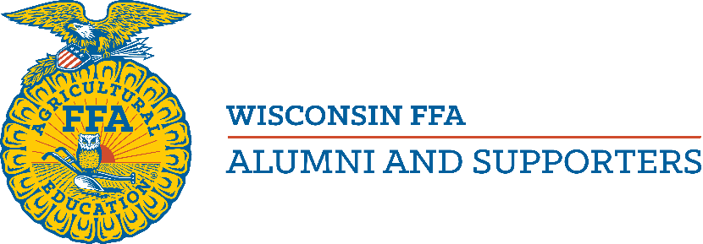
State Level Outstanding Chapter Award
~ THIS APPLICATION IS NOT FOR NATIONAL LEVEL COMPETITION ~
If you are applying at the national level, you are not eligible for this award.

The Wisconsin FFA Alumni and Supporters Association is sponsoring a State Level Outstanding Chapter Award for its smaller chapters. The reasons for this award are:
- It is important that chapters understand how much they do for their local FFA chapters, agriculture education departments and communities. It is also important that chapter FFA members understand how much their local FFA Alumni chapters do for them. Completing the State Level Outstanding Chapter Award application and making it available to both chapter FFA members and FFA Alumni members is one way of increasing this understanding. This is why the signature of the FFA Advisor and a chapter FFA officer are required.
- Wisconsin has several outstanding chapters at the local level. Competing against larger chapters at the national level can often be discouraging for chapters when deciding if they should apply for an award. Having this level of award should help encourage all chapters to complete the award application.
- The National Outstanding Chapter Award application is eleven pages long and requires documentation to be kept throughout the year. The State Level Outstanding Chapter Award application is short, easy to complete. It demonstrates the idea that the primary purposes of a local FFA Alumni Chapter are to support the FFA Advisor, provide opportunities for local FFA members and to advocate on behalf of agriculture education.
- Please send completed application to: execdir@wisconsinffaalumni.org by Nov. 1.

Wisconsin FFA Alumni & Supporters Association
State Level Outstanding Chapter Award Application
~ THIS APPLICATION IS NOT FOR NATIONAL LEVEL COMPETITION ~
Name of chapter:
Mailing address:
Contact Person:
Phone: E-mail:
Number of members (as on current roster) ______
Rules
To be eligible for this award, a chapter must have submitted their membership and payment of fees to the Wisconsin FFA Alumni & Supporters office by November 1.
No single event may be listed more than one time on this application. (For example: Attending an alumni workshop at National Convention cannot be counted as both “attending an official alumni event at National Convention” and as “alumni training” but attending that workshop and the Alumni Awards Presentation could be counted as both.)
Signatures
We, the undersigned, have reviewed this State Level Outstanding Chapter Award application and attest that to the best of our knowledge it has been completed truthfully.
Name: Name: Title: (FFA Alumni Officer – PRINT) (FFA Alumni Officer – SIGNATURE)

Name: Name: (Agriculture Instructor – PRINT) (Agriculture Instructor – SIGNATURE)

Name: Name: Title: (FFA Chapter Officer – PRINT) (FFA Chapter Officer – SIGNATURE)

Section I: Assistance to FFA and FFA Advisor
- Describe up to 5 times that your Alumni chapter worked with FFA members on FFA or agriculture education activities. Include the number of FFA members and FFA Alumni members involved in the activity. (25 points possible)

- FFA Alumni FFA
- FFA Alumni FFA
- FFA Alumni FFA
- FFA Alumni FFA
- FFA Alumni FFA

- Describe up to 5 times that your Alumni chapter provided financial support for your local FFA, local FFA members or your school. Include the amount of money spent and the number of FFA members helped. (25 points possible)

- $ Members
- $ Members
- $ Members
- $ Members
- $ Members

- How many times have FFA Alumni members (other than the FFA Advisor) attended chapter FFA meetings this year? (5 points possible)

- How many times have FFA members attended local FFA Alumni meetings this year? (5 points possible)

- Is your FFA advisor an FFA Alumni officer or elected member of your alumni executive board? yes (0 points) no (5 points)
- Was your FFA advisor the person who completed and/or submitted your roster to the State FFA Alumni office? yes (0 points) no (5 points)
Section I Score: _____ points received out of a possible 70 points

Section II: Advocacy and Community Involvement
- Describe up to 4 ways that your FFA Alumni chapter demonstrated advocacy for agriculture education and/or American agriculture. (20 points possible)

- Describe up to 5 community activities that your FFA Alumni chapter participated in or conducted. This may include fundraising activities. Include the number of FFA Alumni members who participated. (15 points possible)

- Alumni Members
- Alumni Members
- Alumni Members
- Alumni Members
- Alumni Members

- Describe up to 3 methods used to recruit new FFA Alumni members or to retain annual members. (9 points possible)

Section II Score: _____ points received out of a possible 44 points
Section III: FFA Alumni Activities
- Describe up to 2 events of a social nature that your FFA Alumni chapter conducted. Include the number of FFA Alumni members who participated. (8 points possible)
- Alumni Members
- Alumni Members

- Describe up to 2 ways that your Alumni chapters received training relevant to FFA Alumni activities. Include the number of Alumni members that received training. (10 points possible)
- Alumni Members
- Alumni Members

- How many Alumni members attended the Wisconsin FFA Alumni & Supporters Convention? (5 points possible)

- Did your Alumni chapter have a member attend Wisconsin FFA Alumni & Supporters Section meeting? yes (4 points) no (0 points)

- Did your Alumni chapter have a member attend the National FFA Alumni & Supporters Convention and/or attend a National FFA Alumni & Supporters event?
yes (4 points) no (0 points)

- Does your chapter have a member serving on the Wisconsin FFA Alumni State Council, any Wisconsin FFA Alumni committees or on the National FFA Alumni Council? yes (4 points) no (0 points)

Section III Score: _____ points received out of a possible 35 points

Scoring Guidelines for Each Question
Section I: Assistance to FFA and FFA Advisor
- Maximum of 5 points for each entry. 3 points will be given for each entry with an additional 1 point if 5 or more FFA Alumni members participated and 1 more point if 10 or more FFA members participated
- Maximum of 5 points for each entry. 2 points will be given for each entry with an additional 1 point if the amount is between $250 and $499 and an additional 2 points will be given if the amount $500 or more. 1 additional point will be given if 10 or more FFA members benefitted.
- 1 point for each meeting attended up to a maximum of 5 points
- 1 point for each meeting attended up to a maximum of 5 points
- 0 points for yes, 5 points for no.
- 0 points for yes, 5 points for no.
Section II: Advocacy and Community Involvement
- 5 points for each entry.
- Maximum of 3 points for each entry. 2 points will be given for each entry with an additional 1 point is the activity involved 5 or more FFA members
- Maximum of 3 points for each entry. 1 point will be given if the recruitment method is passive, such as mailing a renewal form or handing out a brochure. 3 points will be given if the recruitment method is determined to be “active”.
Section III: FFA Alumni Activities
- Maximum of 4 points for each entry. 3 points will be given for entry with 1 additional point if 10 or more alumni members participated.
- Maximum of 5 points for each entry. 3 points will be given for each entry with 1 additional point if 3 or more Alumni members received training and 1 more additional point if you hosted a training session available to your entire membership.
- 3 points is 1 or 2 members attended, 4 points if 3 or 4 members attended and 5 points if 5 or more members attended.
- 4 points for yes, 0 points for no.
- 4 points for yes, 0 points for no.
- 4 points for yes, 0 points for no.

